PROGRAMMING ASSIGNMENT 1

Project Title : To implement and verify each round of DES algorithm.

System Specification :
OS = Linux (can run using make command)
Language used = C++
Input = 16 char plaintext in hexadecimal, 16 char key in hexadecimal
Output = Keys for 16 rounds (in hex), Ciphertext after each round of encryption (in hex), Plaintext after each round of decryption (in hex).

System Design :
Input: The system takes 64 bit plaintext and key in hexadecimal as input and then converts them into binary form by calling hex to binary conversion module. After that key generation module is called with 64 bit binary key given as input by the user.

Key generation : After converting into binary applying the key generation steps of DES on input key, 48-bit keys for 16 rounds are generated. It takes 64 bit binary key as input and then perform parity drop on the input key. After parity drop, shift left operations are performed on left and right parts of the key. After shift operation, compressed d-box are applied on the key. Finally, the key generated after each round is stored, outputted and then passed to next round to be used for the generation of the key for next step.

Encryption : The input plaintext is converted into binary form. Using keys generated in last step, encryption is performed in 16 rounds and ciphertext in hex at the end of each round is output. It takes the 64 bit plaintext and 48 bit keys generated by key generation module. First of all, initial permutation is performed on the plaintext. Then applying f-box on right part of plaintext and key for that round, the ciphertext is generated for that round which is xor with left part of the plaintext. After swapping left and right part of the generated ciphertext, the ciphertext is outputted and passed as plaintext for next round. After 16 rounds, the final ciphertext is generated after performing the final permutation i.e. inverse of initial permutation.

Decryption : This is the verification step. It takes ciphertext from last step and generated keys as input. Then decryption rounds are performed using keys and plaintext after each round is output. It takes final ciphertext as input, performs initial permutation on that. Then starting from 16 round and moving towards 1st, plaintext is generated for each round after reversing the steps for encryption and finally after initial permutation, the plaintext given as input is generated.

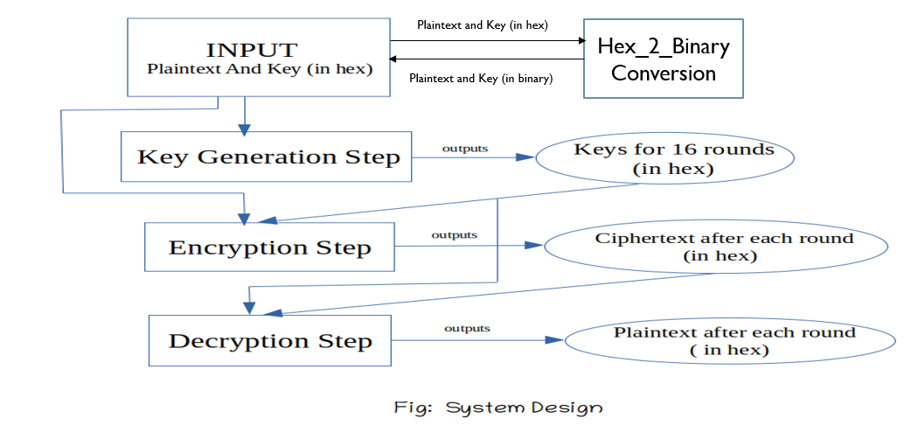

Execution example of the system on a chosen plaintext:

Let the plaintext given as input is : 123456ABCD132536
And the key given as input is : AABB09182736CCDD
